
Real-Time Augmented Reality Overlay for Advanced Data Visualization

Title
Internship Assignment
Summary Of Internship
Name
Soufiane Kissami
r0976650
Bachelor's degree in Computer Science
field AI

Academic year 2023-2024
Campus Geel, Kleinhoefstraat 4, BE-2440 Geel

Internship Project Summary

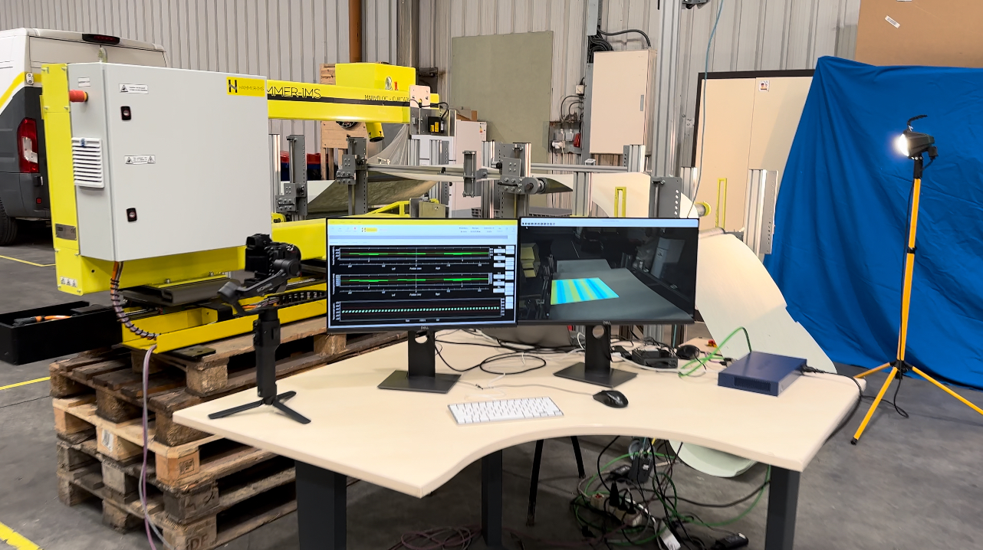

During my internship, I developed an Augmented Reality (AR) system to visually represent basis weight measurement data in real-time. This system integrates a high-end SICK camera with the Harvester library for live video capture and utilizes ArUco markers for precise edge detection of the material under analysis. Using homography transformation, the AR system maps detected coordinates to a fixed reference system and overlays color-map images onto the live feed. This ensures dynamic visualization of measurement data in real-time.

The primary goals of my project included integrating the SICK camera with the Harvester library, implementing ArUco marker detection, applying homography transformation, generating and overlaying color-map images, and ensuring real-time updates by monitoring changes in the CSV file produced by the quality measurement machine. I followed a structured methodology to achieve these objectives.

Firstly, I set up the development environment and connected the SICK camera, capturing and displaying the live video feed using the Harvester library. I then implemented ArUco marker detection with OpenCV, enabling accurate tracking of the material's edges. Homography transformation was applied to map the marker coordinates to a fixed reference system using OpenCV and NumPy, with validation through known coordinates.

Next, I developed a method to generate color-map images based on measurement data using Matplotlib and Pandas. These images were overlaid onto the live feed, with the system continuously monitoring for new measurement data. Real-time updates were facilitated using threading and OpenCV to detect new data and update the color-map images dynamically.

Several challenges were encountered, including ensuring accurate ArUco marker detection in varying lighting conditions, maintaining real-time performance during continuous data updates, and achieving accurate homography transformation with minimal distortion. These were addressed through adaptive thresholding, image preprocessing techniques, threading for asynchronous data monitoring, and extensive testing and validation of transformation parameters.

Despite these challenges, significant milestones were achieved: successful integration of the SICK camera, robust ArUco marker detection, precise homography transformation, and dynamic overlay of color-map images based on real-time measurement data.

The project resulted in an AR system that visualizes measurement data dynamically on a live video feed in the form of color spectrum which interpret-ate results based on color-mapping , demonstrating robust marker detection, accurate coordinate mapping, and continuous real-time updates. This experience enhanced my skills in computer vision, real-time data processing, and AR systems, contributing to my professional growth.

For future work, I recommend improving the marker detection algorithm for more challenging environments, expanding system capabilities by incorporating additional sensors and data sources, and developing a user-friendly interface for easier interaction and visualization control. These enhancements will make the system more versatile and effective in industrial applications.

